Part II: Write an essay on this topic.
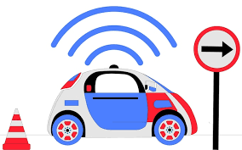
“You'll never catch me in one of those things.” Is this how you feel about driverless cars? Or can you see yourself actually using one? Write about what you think is good and bad about them and whether you trust them to make ethical decisions when lives are on the line and to get you where you want to go safely and reliably.

I think driverless cars is a good idea overall, but right now I would get into one only in designated area, where no one can affect my ride. Driverless cars is good for the environment, you don’t have to hire or be the driver to get from A to B. Theoretically you actually would be safer in driverless car than in regular car. The downside is you feel not in control, vulnerable, because something is driving your car and it’s not even human. And other people can affect your journey up to hurting you. Maybe it will be a regular driver that driving his car like humans do, it can be unstable, unpredictable, can lead to a crash. Or maybe it will be an evil hacker that hijacks your vehicle and use it to his own benefit. I think I don’t trust manufacturer with ethical decisions, but if it were regulated by the government I would be more inclined to trust a driverless car. All thing considered it is a good technology and it will be even better in the future, but right now it’s risky.

